Gaussian reduction in t_eq
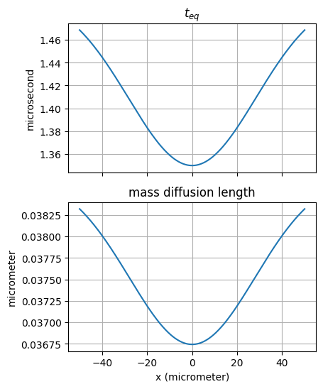
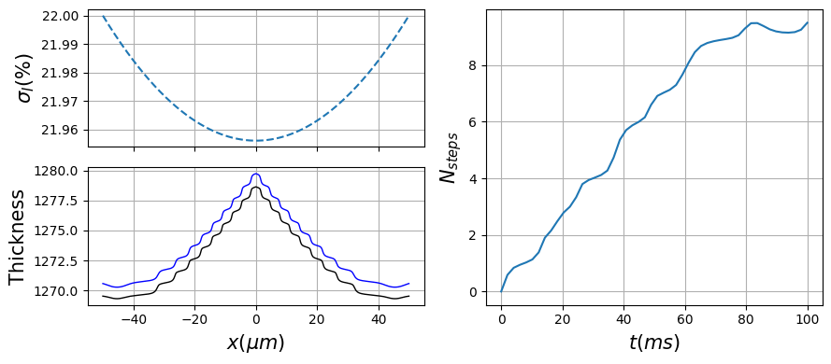

Super-Gaussian reduction in t_eq
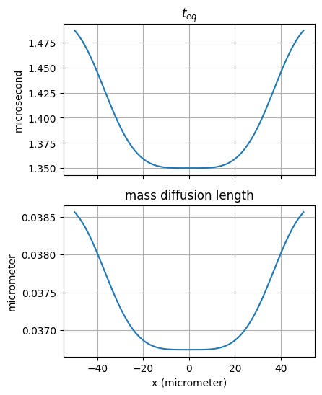
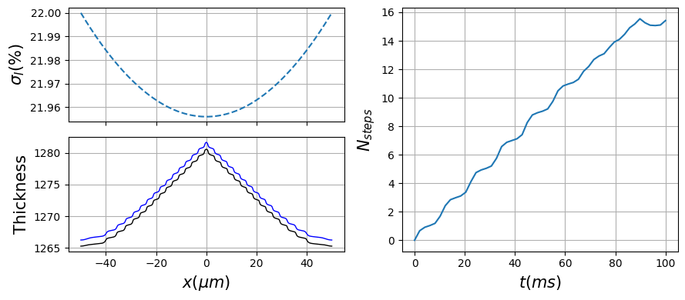

Two-peak Gaussian reduction in t_eq
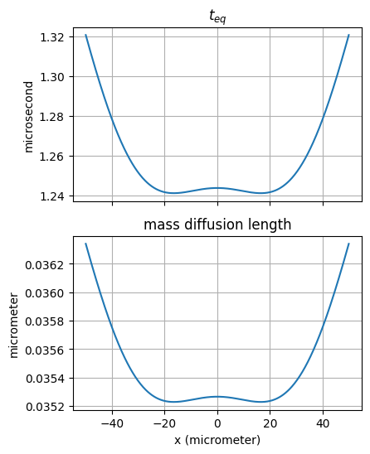
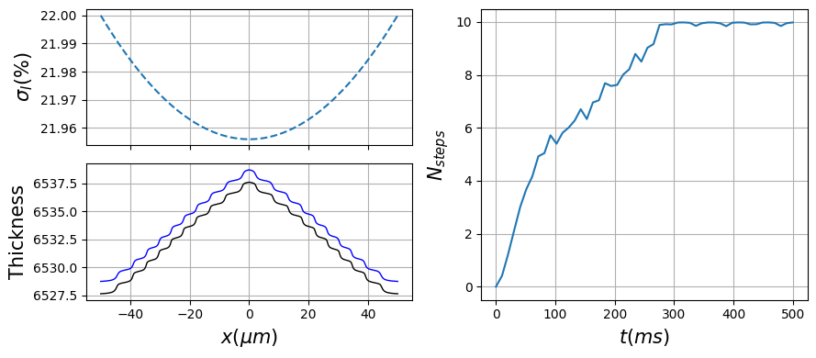

Using these parameters (except for adjustments in the runtime

&GI
sigma0 = 20
sigma0_units = 'percent'
sigmaI_corner = 22
sigmaI_corner_units = 'percent'
c_r = 0.2
c_r_units = 'percent'
nu_kin = 0.264
nu_kin_units = '1/microsecond'
t_eq = 1.5
t_eq_units = 'microsecond'
nx_crystal = 501
Nbar = 1
Nstar = .1
h_layer = 0.37
h_layer_units = 'nanometer'
D = 0.001
D_units = 'micrometer^2/microsecond'
L = 50
L_units = 'micrometer'
d2Ntot_dx2_threshold = 10000
d2Ntot_dx2_threshold_units = '1/micrometer^2'
/

&RT
runtime = 200
runtime_units = 'ms'
ntimes = 50
odemethod = 'RK45'
verbose = 0
/

